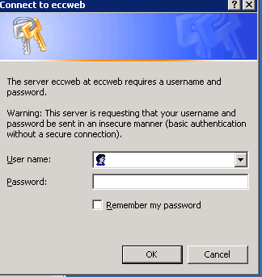
THE CHANGE MANAGEMENT PROCESS

We have developed a web based system to track our change management process. The page can be located at http://eccweb/index_services.htm.

When you connect you will see a standard Login / Password dialog.
Use your windows credentials -> use AD\login for your login.

Change Entry

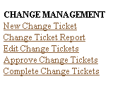
The left side of the Enterprise Dashboard contains the
table of contents for the Service Dashboard.

Select “New Change Ticket”

This will bring up the New Change Ticket Entry Screen.

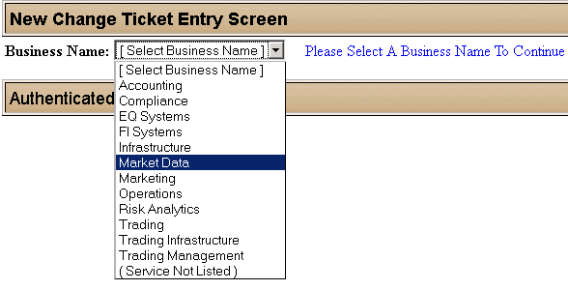
You will now need to select a service to log your change – the services are categorized by line of business for ease of use.

Select Business Name

Note that you can change your business name at any point, which will change the internal service drop down but which will otherwise leave all data on the form unchanged.

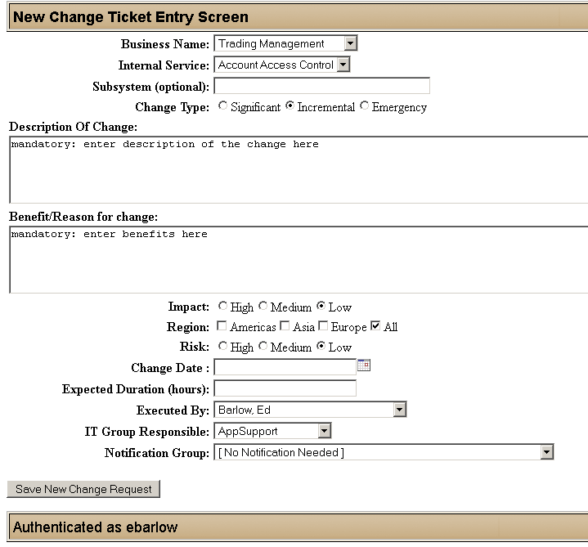
You can use the Subsystem field to further identify the change -> the system name of a single system change
would be a good value to enter.

Change Types
- Significant – Normal scheduled changes
- Incremental – Small changes with Low risk & Impact
- Emergency – Changes requiring immediate implementation

Enter Description of Change & Benefit/Reason

Duration is in hours: .1 hour== 10 minutes, .5 hours== 30 minutes
The Notification Group and Executed By will be emailed whenever the status of a ticket changes. Click Save New Change Request to save your change. Save New Change Request will result in a screen confirming the save:

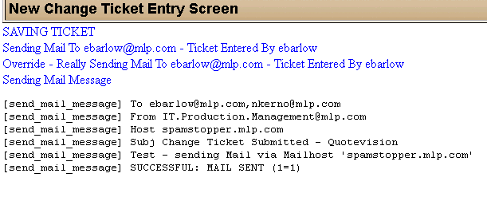
Your ticket is now saved in the system

Change Approval
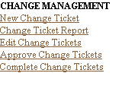
Most system users do not not have this option enabled. You must be in the LDAP group “ChangeApprovers” to see this item

Select Approve Change Tickets
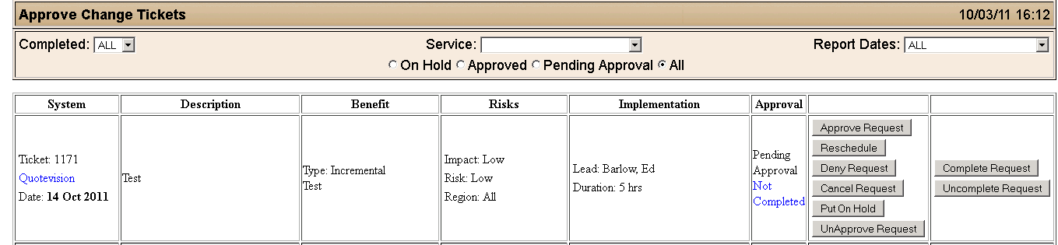

The first set of buttons ( Approve/Reschedule/Deny… ) control the state of a ticket. Mail will be sent out to interested parties when the state of a ticket is changed. The last two buttons will mark the change as completed (or mark it incomplete).

Marking Changes Completed
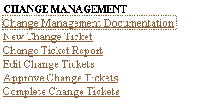
This option is on for all system users. You should use it to identify when the change ticket has been completed

Select Complete Change Tickets

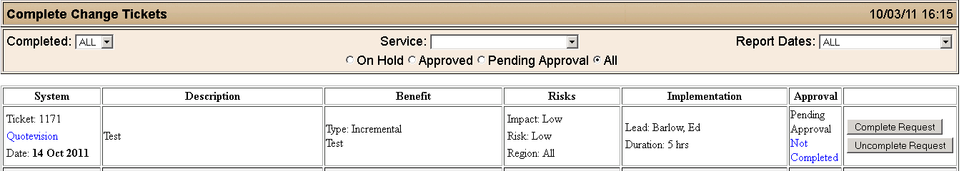

Change Workflow

Once you have submitted your change ticket, it will be reviewed by the change management committee. Changes are grouped by change type: Significant, Incremental, and Emergency. This change type field impacts the process work flow. Most changes should be marked as Significant, which mean they are discussed at the weekly change meeting, approved, and scheduled. Incremental changes are NOT reviewed at this weekly meeting, and can be approved by the appropriate team lead. Emergency changes are rushed, and circumvent the normal change approval process by requiring a team lead to specify that the change is appropriate and safe by allowing them to approve the change. Team leads are identified by their existence in the ChangeApprovers group.

Mails are sent out after each change in ticket state to the person who will execute the change and to Notification group.

Significant Changes
A significant change will be reviewed at the weekly change management meeting. After approval in the meeting, the ticket will be marked approved (which will send a mail) and scheduled. Once the work is completed, the person who executed the change should mark the ticket completed

Incremental Changes
An incremental change is not reviewed by the change management meeting. It is, instead, approved as safe by a team lead. This is to track minor changes that have low impact and risk.

Emergency Changes

An emergency change is one to address either an issue that’s already occurred or one that’s about to happen.

An emergency change is also not reviewed at the change management meeting. It is, instead, approved as safe by a team lead. Once the approver signs off, mail goes out to notification group and ChangeManagement@mlp.com.

